# Integrated Mobile Applications Development

# Lab 6 Routing

**NOTE: When creating an Ionic App for each of the questions in this lab use:**

**ionic start *appName* blank**

## Part 1 - Routing

1. Write an Ionic Application that uses AngularUI Routing to display a template file (called home.html) in the main index.html page.

The template file should contain two p elements inside an ion-view:

Shopping List

ToDo List

The URL shown on the web browser should be:

homeUrl

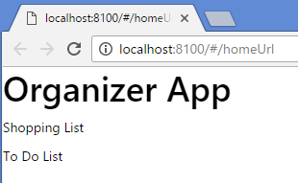

1. Update Question 1 so that instead of displaying 2 p elements, the home.html template file now looks as follows:

<ion-view>

<a ng-href="#/shoppingListUrl">Shopping List</a>

<br/>

<a ng-href="#/toDoListUrl">To Do List</a>

</ion-view>

If the ‘Shopping List’ link is clicked, a template file called shopping-list.html which contains the follows is displayed:

<ion-view>

<p>Milk</p>

<p>Bread</p>

<p>Cheese</p>

<p>Butter</p>

</ion-view>

If the ‘To Do List’ link is clicked, a template file called todo-list.html which contains the follows is displayed:

<ion-view>

<p>Wash Dishes</p>

<p>Fix Car</p>

<p>Pay ESB</p>

<p>Write App</p>

</ion-view>

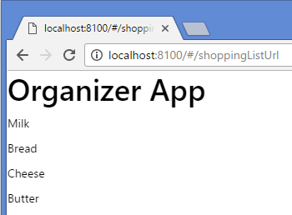 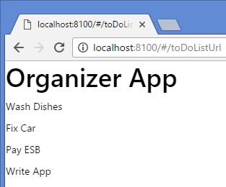

1. Update Question 2 so no hard-coded data is stored in either shopping-list.html or todo-list.html.

Instead the data which was previously hard-coded should be stored in Controllers.

1. Update Question 3 so that when a shopping item, or todo item is clicked template files called shopping-item.html and todo-item.html respectively, which contain the following code are displayed:

<ion-view>

<p>You clicked a Shopping Item</p>

</ion-view>

And

<ion-view>

<p>You clicked a Todo Item</p>

</ion-view>

Ensure the URL displayed in the browser is shoppingListUrl/ITEM, where ITEM is the shopping list item clicked.

Ensure the URL displayed in the browser is toDoListUrl/TODO, where TODO is the ToDo list item clicked.

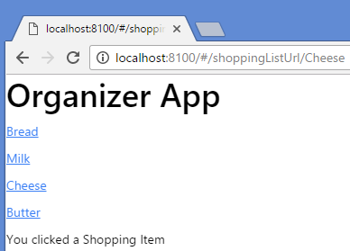

1. Update Question 4 so instead of displaying ‘You clicked a Shopping Item’ shopping-item.html now says ‘You clicked a Shopping Item ITEM’ where ITEM is the name of the shopping item selected.

